Hackerrank question
Printing Pattern Using Loops | HackerRank
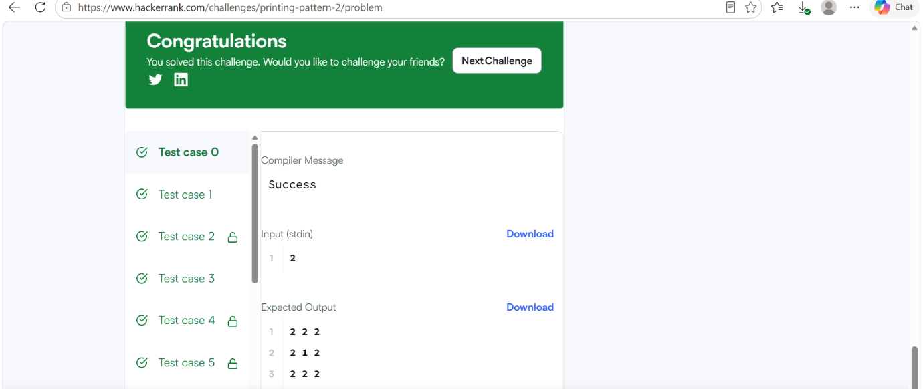

Code
#include <stdio.h>
#include <string.h>
#include <math.h>
#include <stdlib.h>
int main()
{
int n;
if (scanf("%d", &n) != 1) return 0;
int size = 2 * n - 1;
for (int i = 0; i < size; i++) {
for (int j = 0; j < size; j++) {

int min_row = i < size - 1 - i ? i : size - 1 - i;
int min_col = j < size - 1 - j ? j : size - 1 - j;
int min_dist = min_row < min_col ? min_row : min_col;
printf("%d", n - min_dist);
if (j < size - 1) {
printf(" ");
}
}
printf("\n");
}
return 0;
}

